**Department of Mechanical Engineering**

**GED 1201 Engineering Mechanics (Tutorials)**

**Part B and C type of problems**

1. A uniform ladder of weight 850 N and of length 6 m rests on a horizontal ground and leans against a smooth wall. The angle made by the ladder with horizontal floor is 65°. When a man of weight 750 N stands on the ladder at a distance of 4 m from the top position of ladder, ladder is at the point of slip. Determine the coefficient of friction between the ladder and floor.

2. A ladder 5 m long and 250 N weight is placed against a vertical wall in a position where its inclination to the vertical 30°. A man weighing 800 N climbs the ladder. At what position will he induce slipping? The coefficient of friction for both the wall and floor is 0.2.

3. Block A 20 N and block B 30 N, is placed on an inclined plane as shown below. Assume the coefficient of friction between all the contact surfaces as 0.15, both the blocks were connected together by a rope which passes through a frictionless pulley. Determine the angle of inclination.

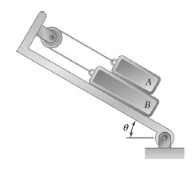

**Part A type of questions**

1. Define the term friction.

2. Why the coefficient of frictional value is always less than 1?

3. What do you mean by dry and wet friction?

4. Define angle of repose or angle of friction.

5. State static and dynamic friction.

6. State law of solid or coulomb law of friction.

7. In a ladder problem, the ladder will be always slipping at floor or wall. Justify your comment on it.

8. Draw a ladder which rest on a wall and floor, also show their corresponding reactions and frictional forces induced.